**Network Fundamentals Week 8 Log Book**

**Summary**

We setup a peer-to-peer network of two computers via a crossover Ethernet cable. Compared to a standard Ethernet cable, the internal wiring of the crossover cable reverses the transmit and receive signals. Once the two PC’s are connected via a Ethernet cable we can begin to setup the network with the network settings in control panel on windows.

**Implementation**

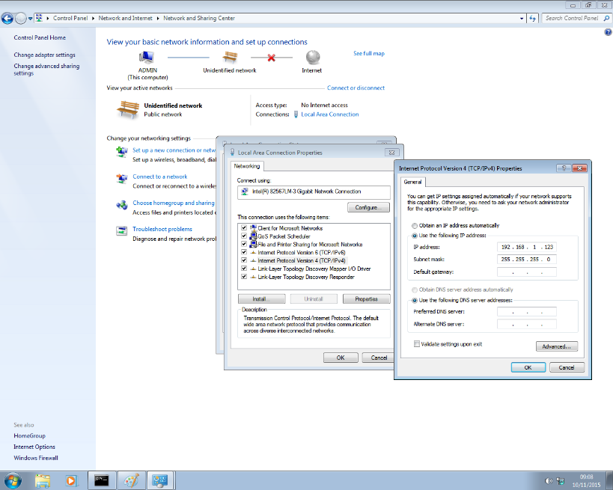First we connected the two computers via an Ethernet cable. Once this was complete we could begin create the local network on the operating system. The first thing we had to do was setup an IP address for each computing. To do this we went to control panel 🡪 network and sharing centre 🡪 local area connection and then IPV4 properties. Here we can change the PC’s IP address and subnet mask. We gave each computer a separate, unique IP address and clicked OK.

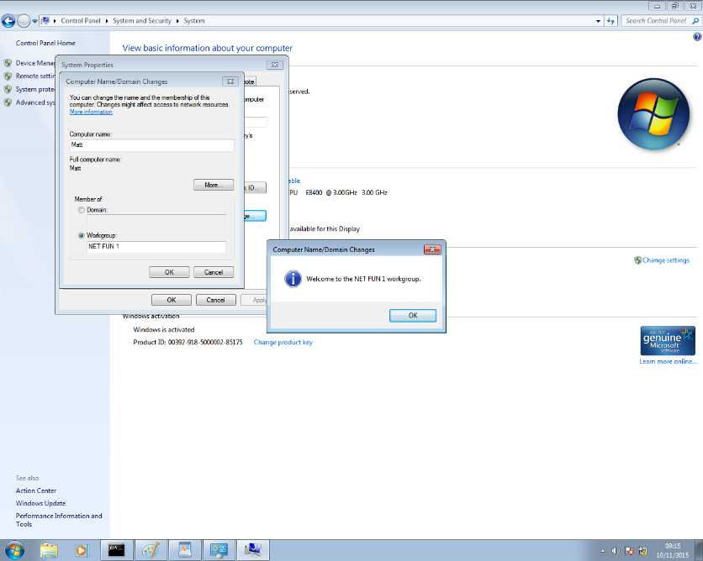After this is completed we need to give our computer a name so that it can be recognised by another user in the same network, in the screenshot on the left you can see this process. You can also choose a workgroup on the network that already exists and join it from this panel which I have also done. This means that my computer is now in the workgroup called NETFUN1 which is shared across the network.

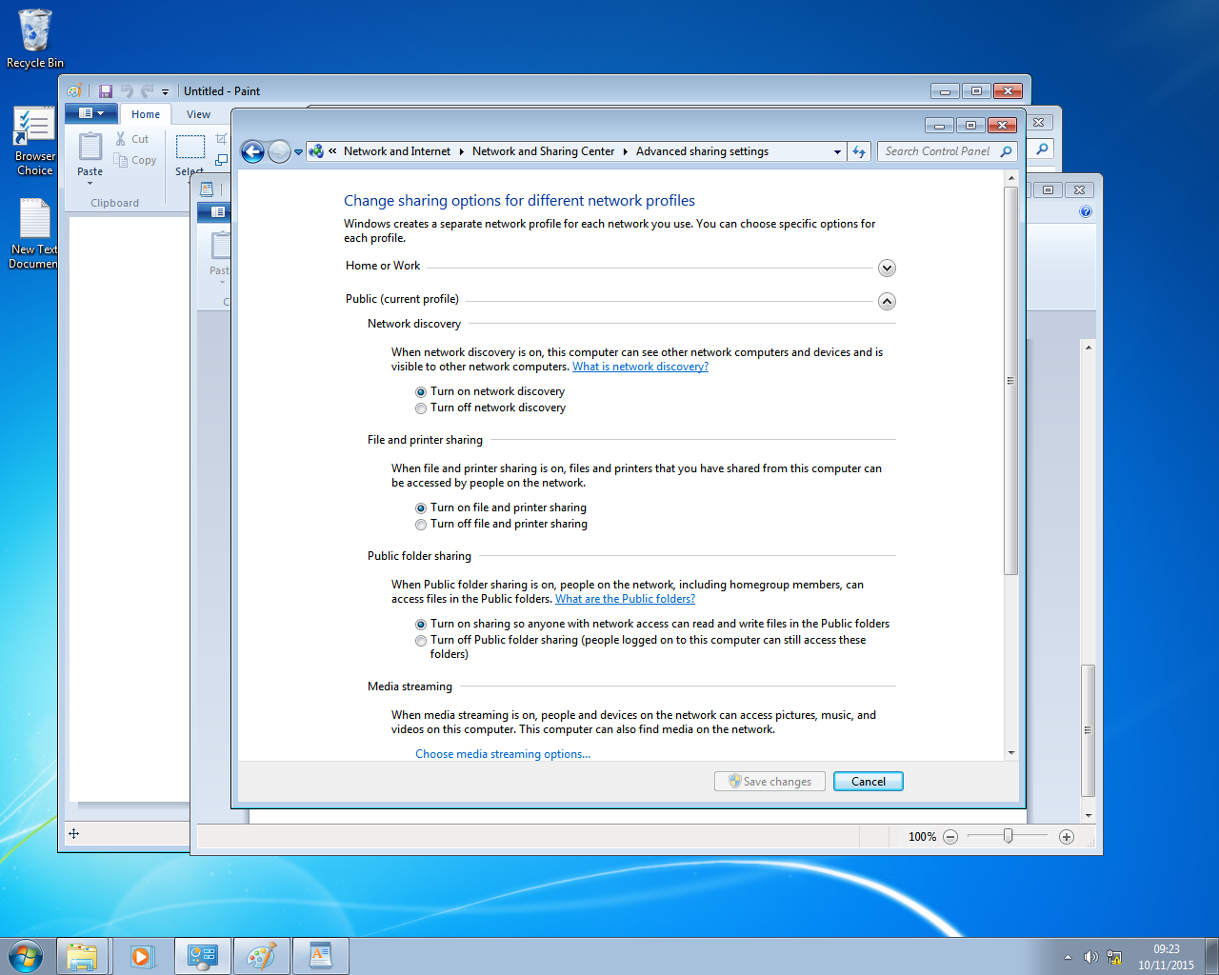At this point in time though I can’t be seen by other people on the network. First I need to go in to networking and sharing centre and advanced sharing settings. From here I need to turn on network discovery so that the computer can be seen by other devices on the network and workgroup.

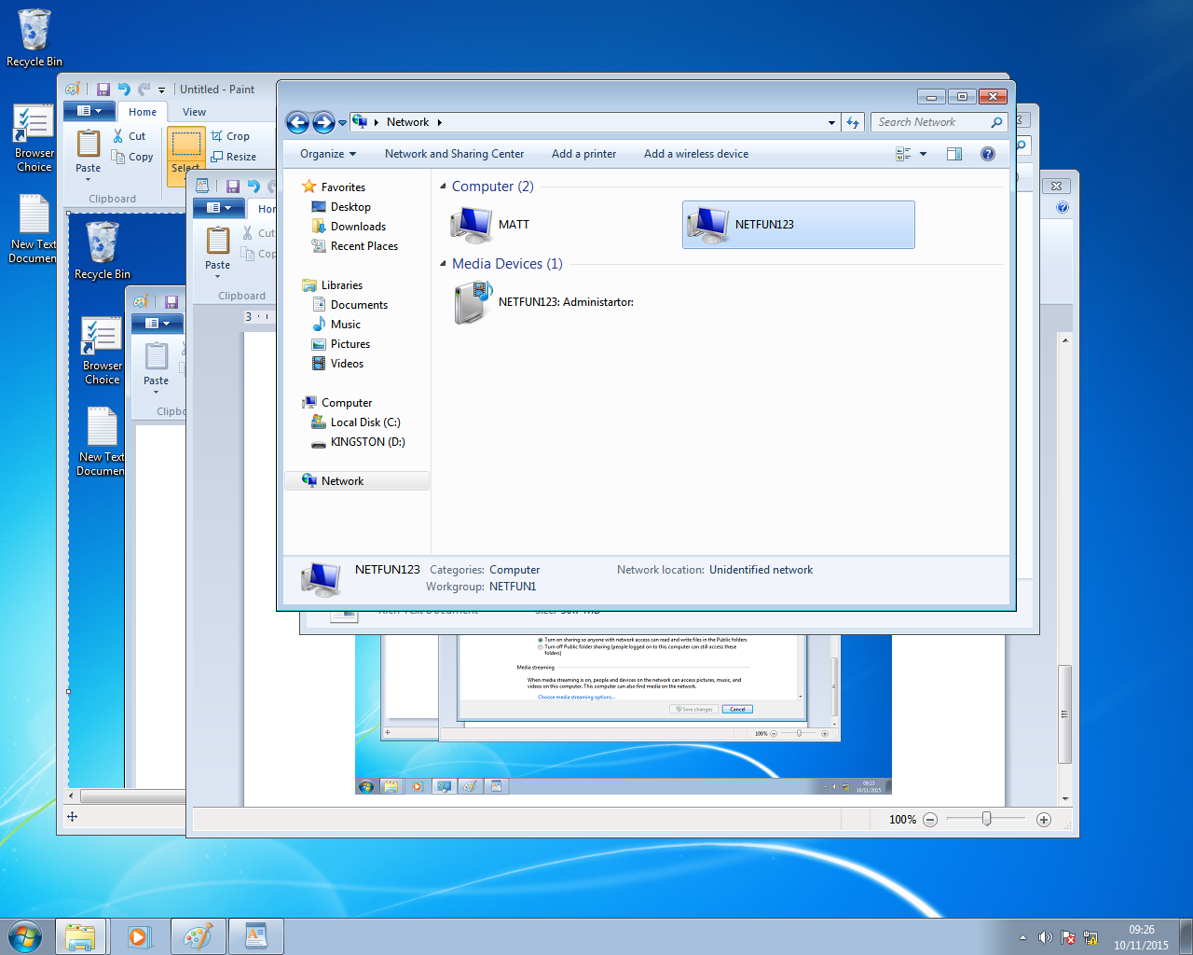

Now if we check “Network” we can see the NETFUN123 which belongs to workgroup NETFUN1. This is the other computer that we are trying to connect to and I can now click on it and open it up. From here we can communicate with the computer.

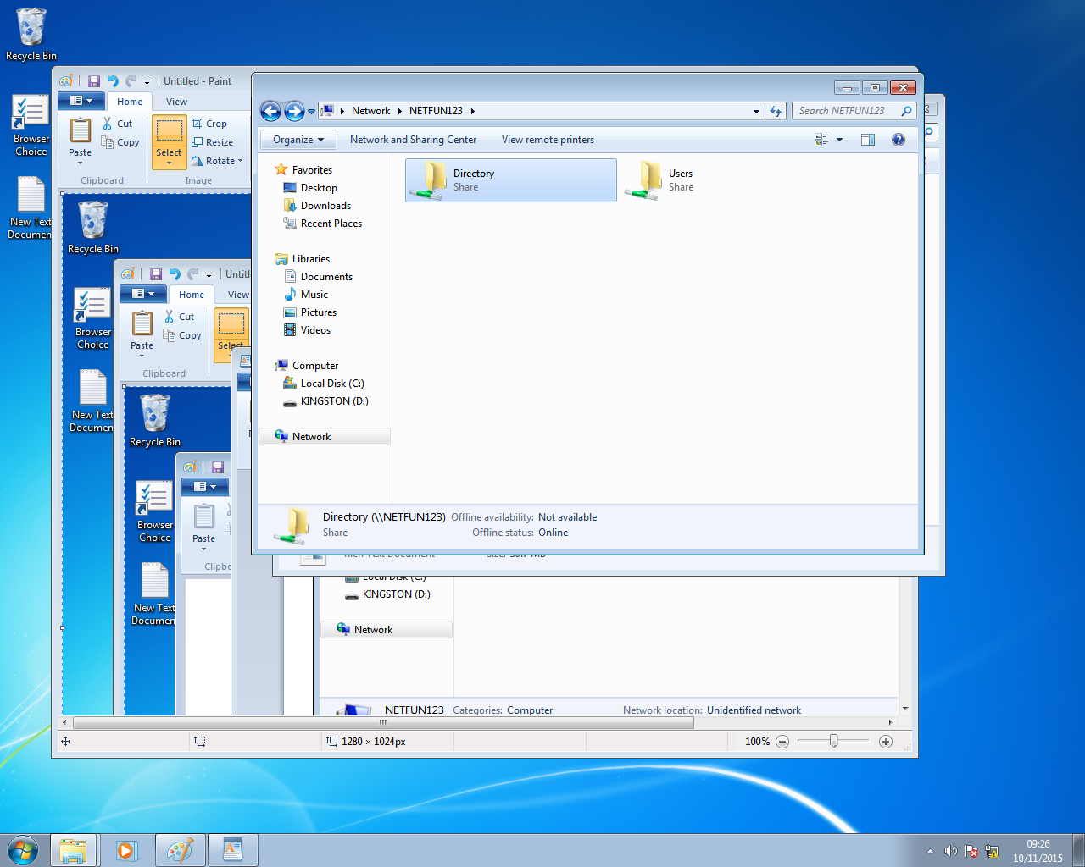

From here we can communicate with the computer and do things such as creating new directories and files. As we can see here we created a new folder called “Directory”.

**Results**

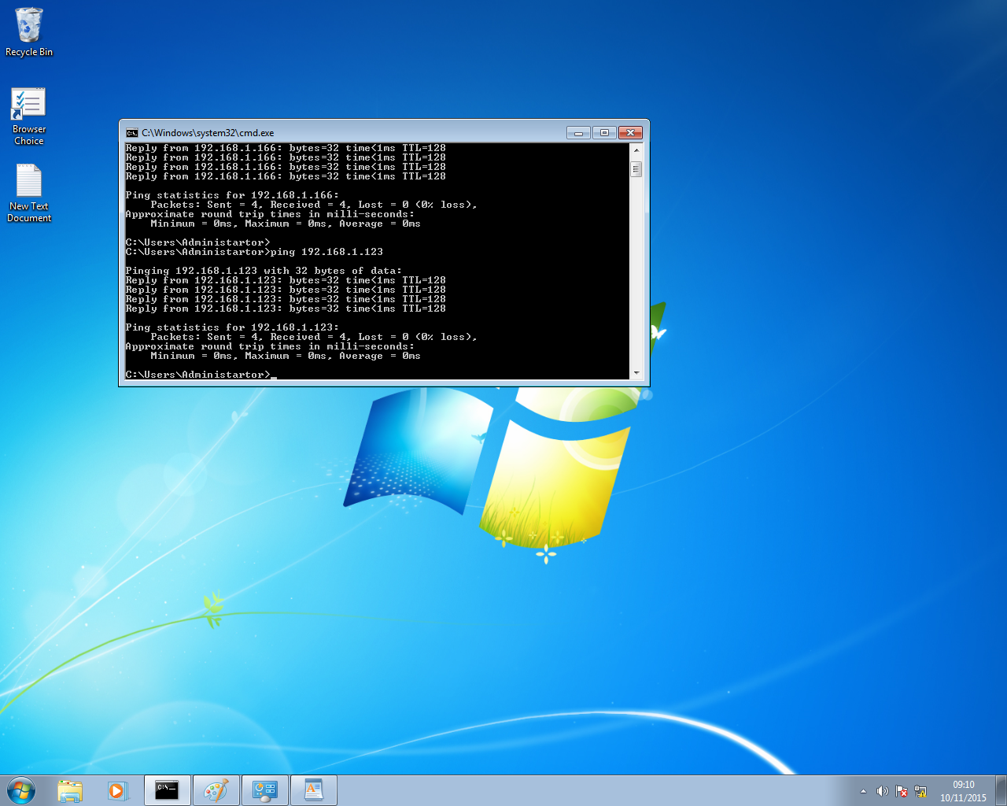We managed to connect both computers together relatively easily and without too much hassle. One good test we did even before we started setting up the network was to ping the other person’s machine first to see if we could transfer information and get a response. We can do this via the command line in windows just by typing: ping *ip address*

As you can see in the screenshot this worked fine. We sent 4 packets to the other computer and received 4 as well. This shows that the two computers should be able to connect to each other.

**Questions**

* What are the advantages and disadvantages of this version of a peer-to-peer network?

Advantages

1. Easy and quick communication
2. Less chance of data loss during communication
3. Less chance of network failure due to an intermedium device such as a hub
4. Less traffic
5. Cheap

Disadvantages

1. Very small network, can be extended with hubs and/or switches
2. Short wires
3. Short travel distance
4. Speed and load limited to the Ethernet cable

* When would using this topology be beneficial to an organisation?

A small organisation that has a most of their PC’s in one room. If they need to share files between 2 PC’s then it is ideal.

**Conclusion**

This is a very basic network but it does have its uses. It is cheap and cost effective but is very limited in what it can do.